

Marwadi Education Foundation ’s Group of Institutions Gauridad Campus, Rajkot
DEPARTMENT OF INFORMATION AND COMMUNICATION TECHNOLOGY

AI Playground: Unlock the Power of Prompting

Date: 30-08-2025

Event Report



Marwadi Education Foundation ’s Group of Institutions Gauridad Campus, Rajkot
DEPARTMENT OF INFORMATION AND COMMUNICATION TECHNOLOGY

Work and Flow of Event:
The event “AI Playground: Unlock the Power of Prompting” organized by the Data Science Club at Lab MA112 for first-semester ICT students began with an icebreaker activity and introduction to prompting. This was followed by a session on prompt engineering fundamentals and then a hands-on AI tool exploration where students rotated across stations for text, image, PPT, and fun AI tools.
After the lunch break, an AI Quiz and Prompt Challenge was conducted, where participants guessed prompts and worked on creative tasks. Following this, all participants were divided into six teams and assigned the task of creating an
AI-generated PPT on the topic “AI is not good for academics.” Each team presented their work before the audience, and the results were declared based on a voting system.
The event concluded with a wrap-up, key takeaways, and group photo.

About DS club:
The session starts with the introduction of DS Club, developed by students of ICT department and guided by Professor Nishith Kotak of ICT department, aims to explore vastness of Data Science and Data visualization. The club also aims to teach their members that how data can be used to find conclusions and make correct decision after correct analysis of data.

Intro To What is AI and Event intro?
The event commenced with a warm welcome address by the Data Science Club members, where they introduced the aims of the workshop and highlighted the significance of AI in today’s academic and professional landscape. To set an engaging and lively atmosphere, an icebreaker activity was organized using Canva Magic Write and Suno.ai, where an
AI-generated song on the theme “Indian Traditional Food” was played. This unique blend of creativity and technology immediately captured the participants’ attention, evoked curiosity, and encouraged active involvement right from the beginning


- Introduction to Prompt Engineering:-
Following the icebreaker, the event transitioned into a focused session on Prompt Engineering. The members of the Data Science Club provided a comprehensive introduction to this critical skill, defining what prompts are and explaining their role as the 'language' of communication with AI models. The session highlighted the fundamental principles and golden rules of effective prompting, such as being specific, providing context, and defining the desired output. To reinforce these concepts, a series of practical examples were shared, showcasing the difference between poorly framed and well-structured prompts, which provided a clear and practical understanding for all the participants.

AI Tools Exploration:
Following the foundational session on prompt engineering, participants were given a hands-on opportunity to explore a diverse range of AI tools. This practical segment was designed to provide students with real-world experience across different AI applications. The tools explored included text-based assistants like Claude and Google NotebookLM, which demonstrated the power of conversational AI and research summarization. Students also experimented with AI for content creation, using Canva Magic Write and Canva Picture Generator for text and image synthesis, and presentation tools like Slidesgo, Popai, and Gamma. Furthermore, they were introduced to advanced multimedia AI, including Suno.ai for music generation, ElevenLabs for voice synthesis, and HeyGen for creating
AI-generated videos. This immersive, station-based approach allowed students to gain practical exposure to a wide array of AI capabilities in a stimulating and interactive environment.



Marwadi Education Foundation ’s Group of Institutions Gauridad Campus, Rajkot
DEPARTMENT OF INFORMATION AND COMMUNICATION TECHNOLOGY

Quiz and PPT Challenge:-
After a refreshing lunch break, the energy was high for the AI Quiz and Prompt Challenge, an interactive session designed to test the participants' understanding of the concepts covered. Following the quiz, the students were divided into six teams and given a competitive task: to create an AI-generated PPT on the topic “AI is not good for academics.” This challenge required them to use their newly acquired prompting skills to structure a compelling presentation, encouraging both teamwork and creative thinking.

Winner Declaration and Conclusion:
The culmination of the workshop was marked by the group presentations of the AI-generated PPTs. Each of the six teams presented their unique perspectives, and the winners were chosen through a live voting system by the audience, adding an element of friendly competition and peer recognition. Following the exciting winner declaration for both the quiz and the PPT challenge, the event concluded with a wrap-up session that summarized the key learnings. A celebratory group photo was taken to commemorate the successful workshop, leaving participants with a sense of accomplishment and a shared memory of a truly insightful and engaging event.Winners of quiz and ppt presentation have been awarded by exclusive Eudemy courses. And all the participants were encouraged by giving them E-Certificates of participation.

Course given to:-
1. ppt presentation competition winners-From Prompt to Photorealism: Midjourney Image Creation Guide.
3. quiz winners- AI Mastering Prompt Engineering



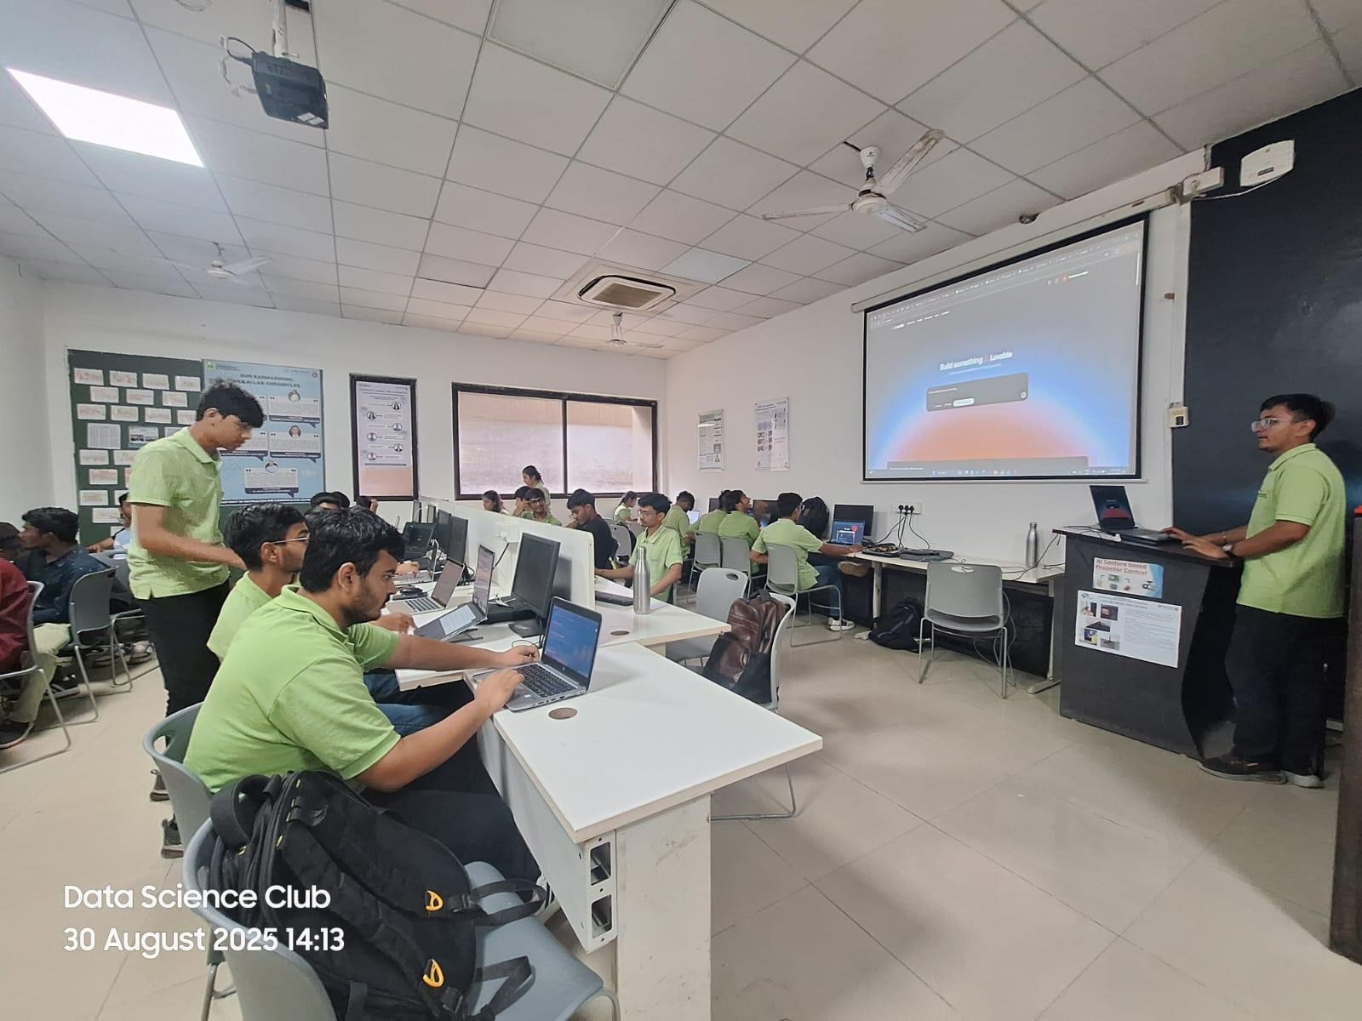
MARWADI EDUCATION FOUNDATION ’S GROUP OF INSTITUTIONS GAURIDAD CAMPUS, RAJKOT DEPARTMENT OF INFORMATION AND COMMUNICATION TECHNOLOGY

Photos:


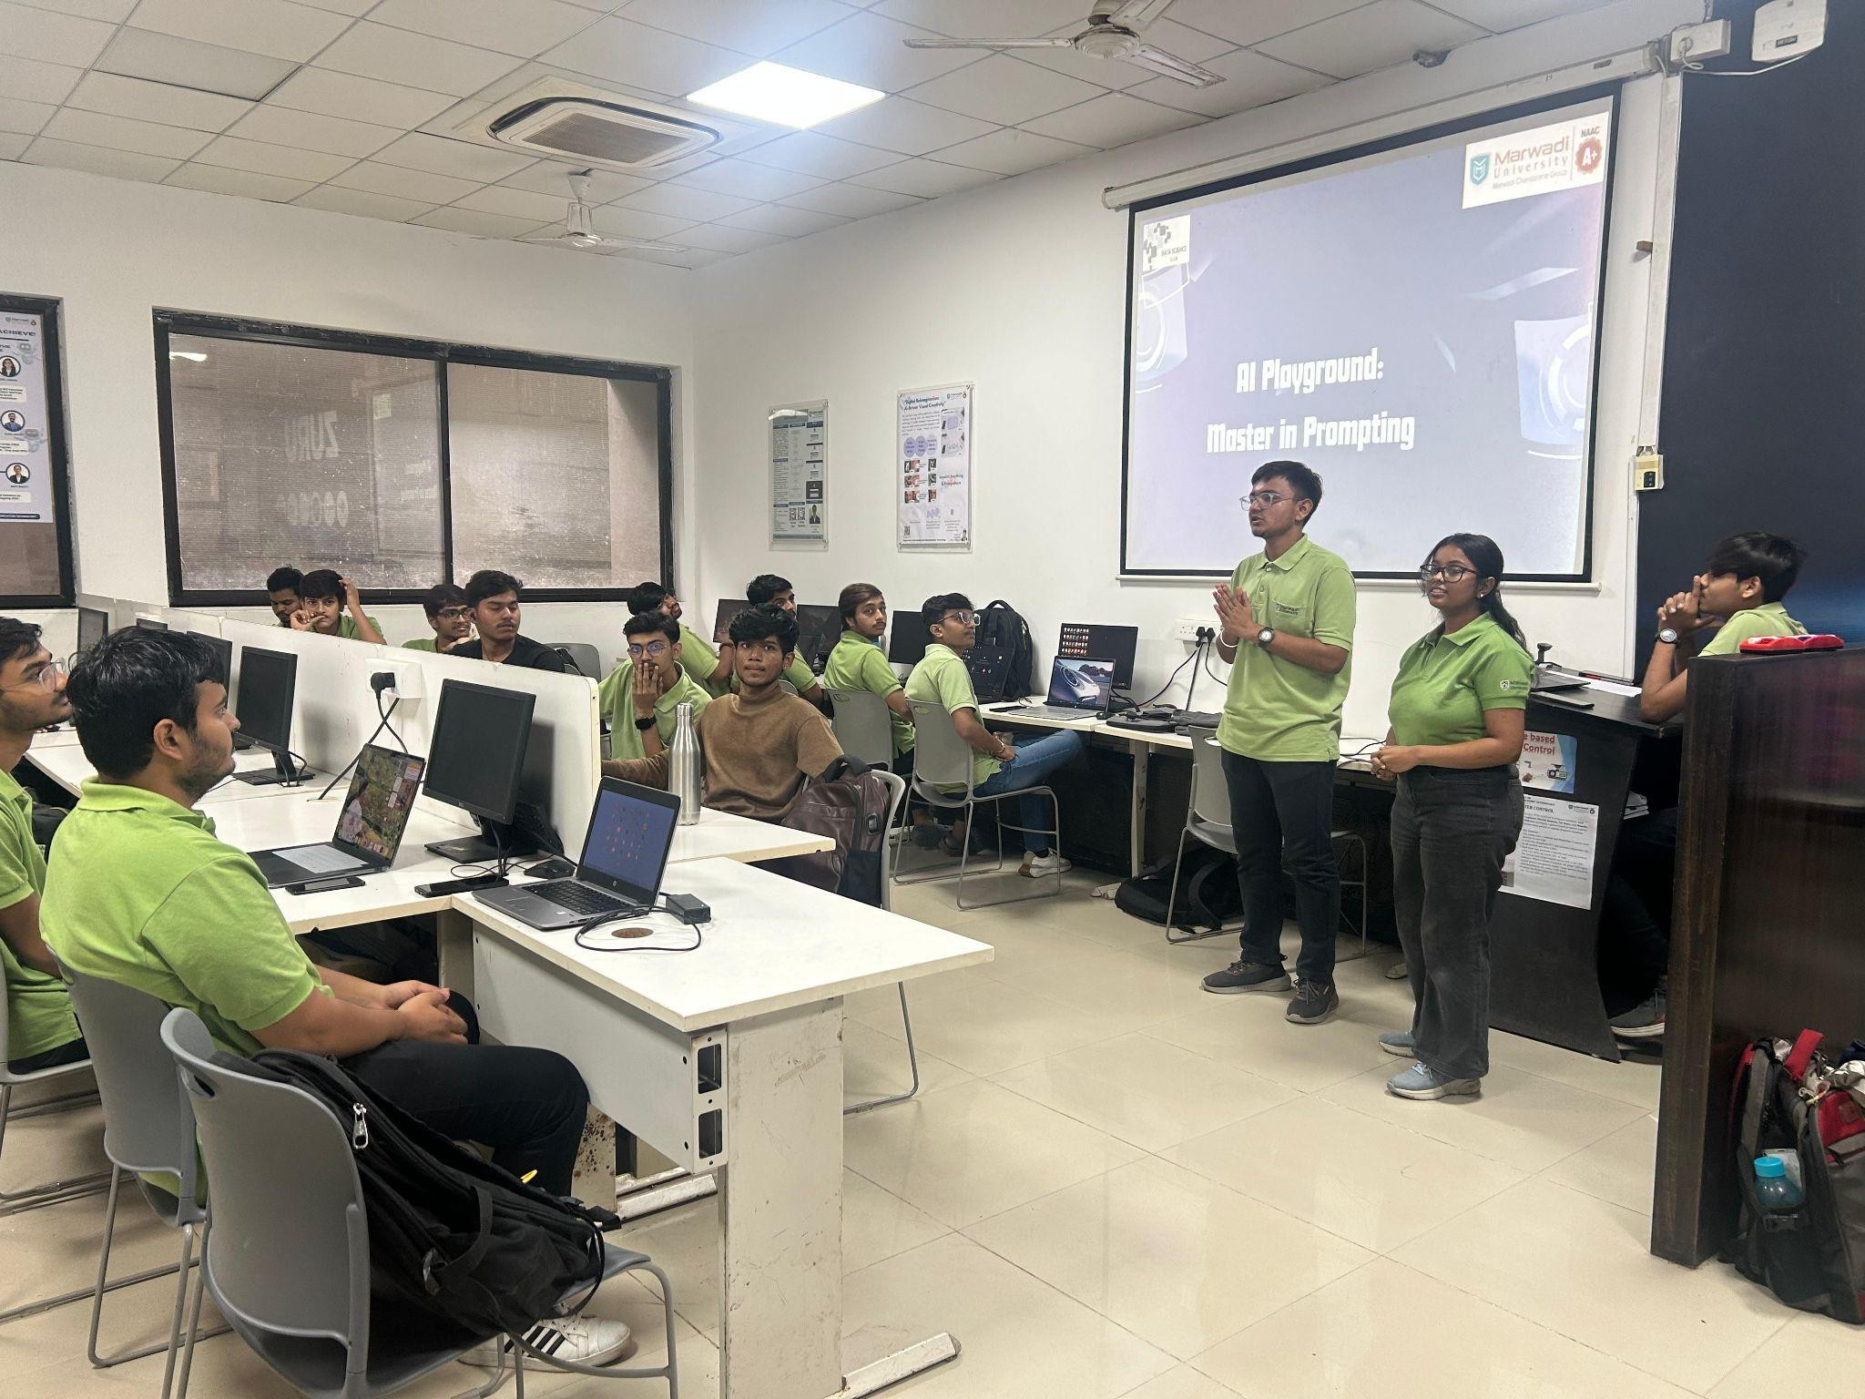
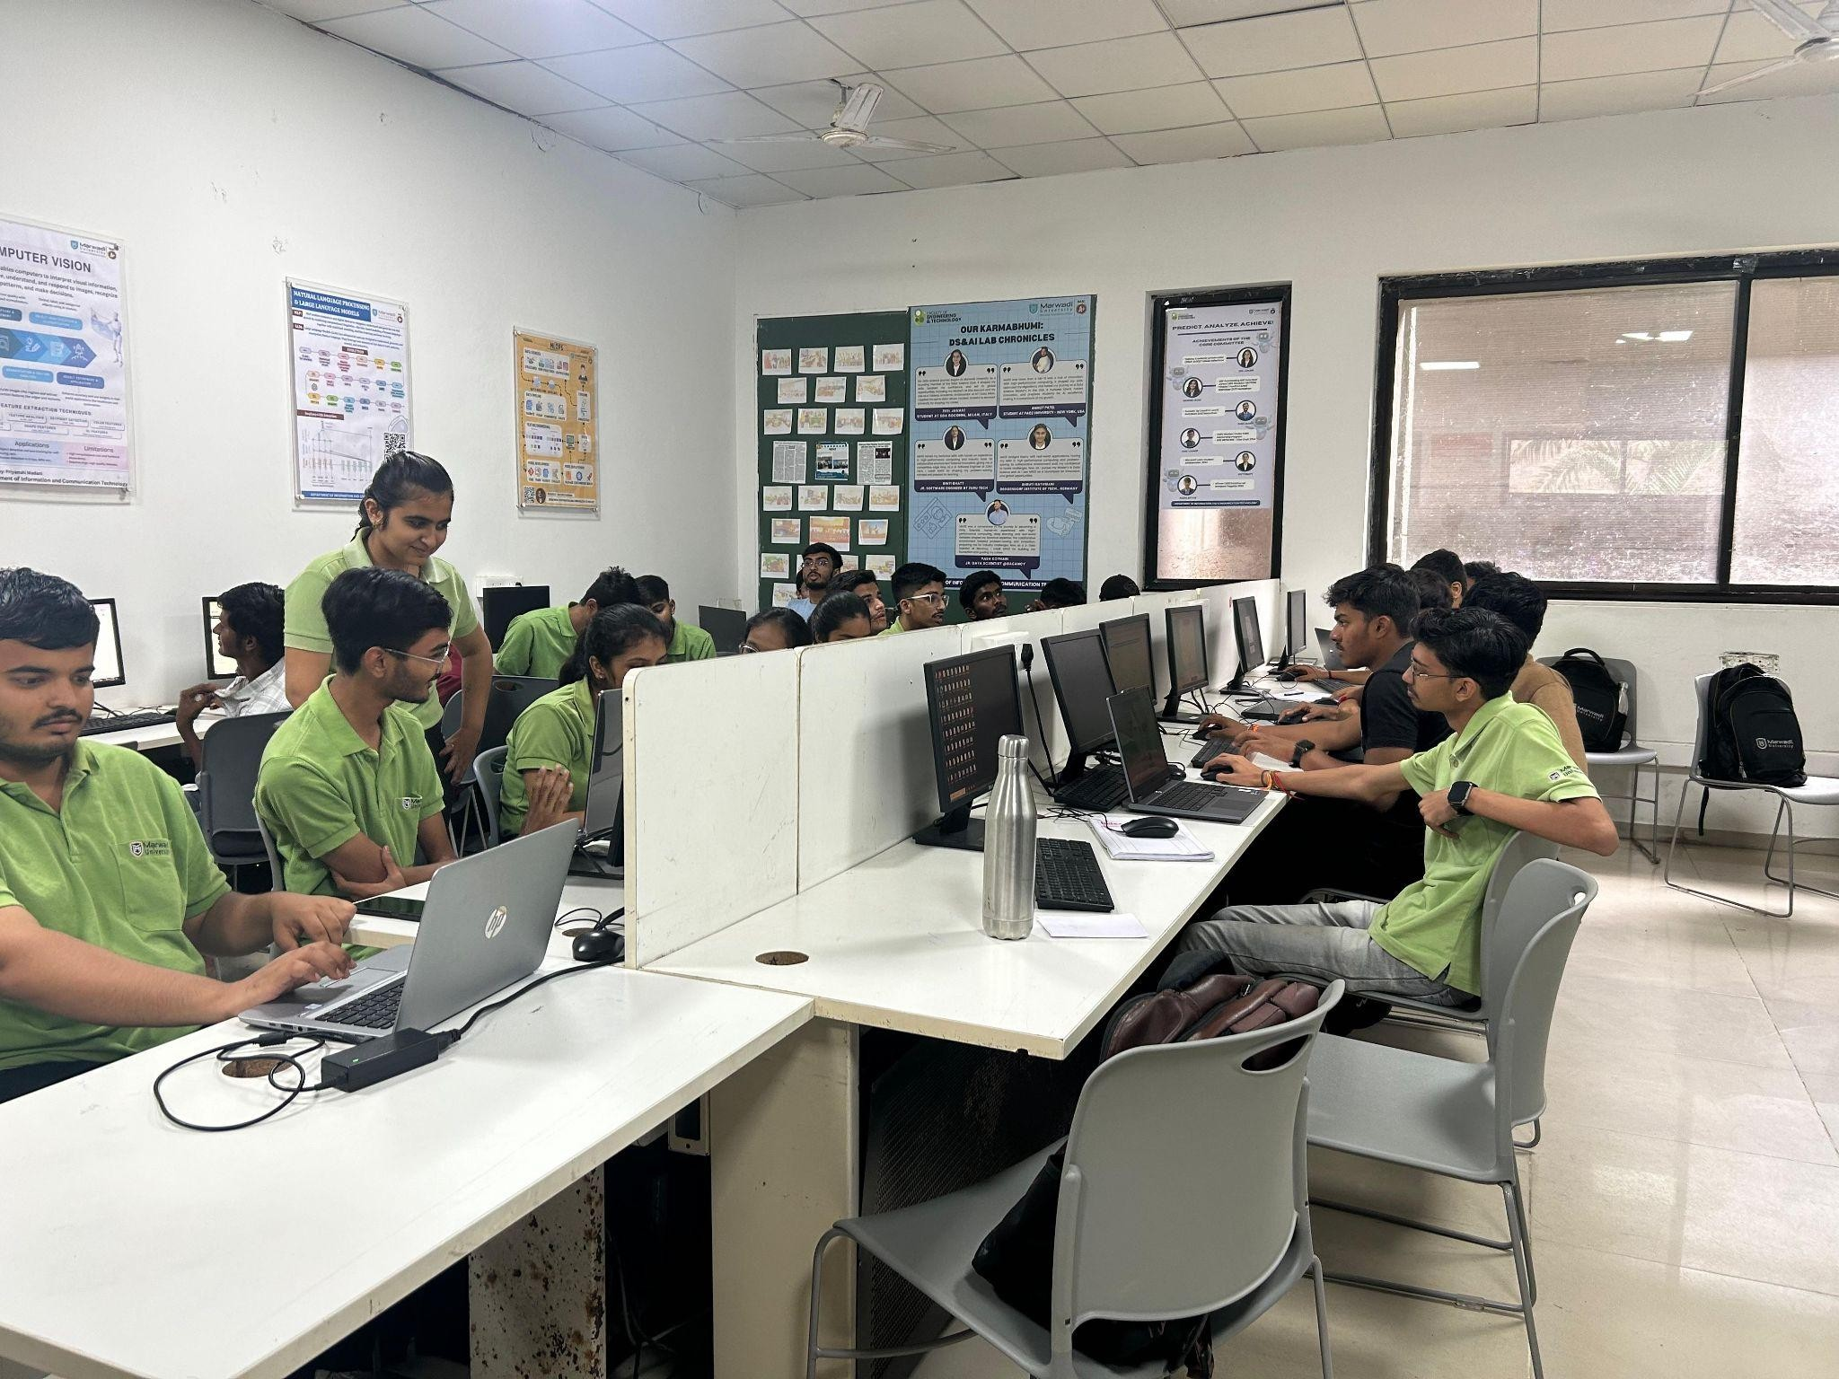

Marwadi Education Foundation ’s Group of Institutions Gauridad Campus, Rajkot
DEPARTMENT OF INFORMATION AND COMMUNICATION TECHNOLOGY

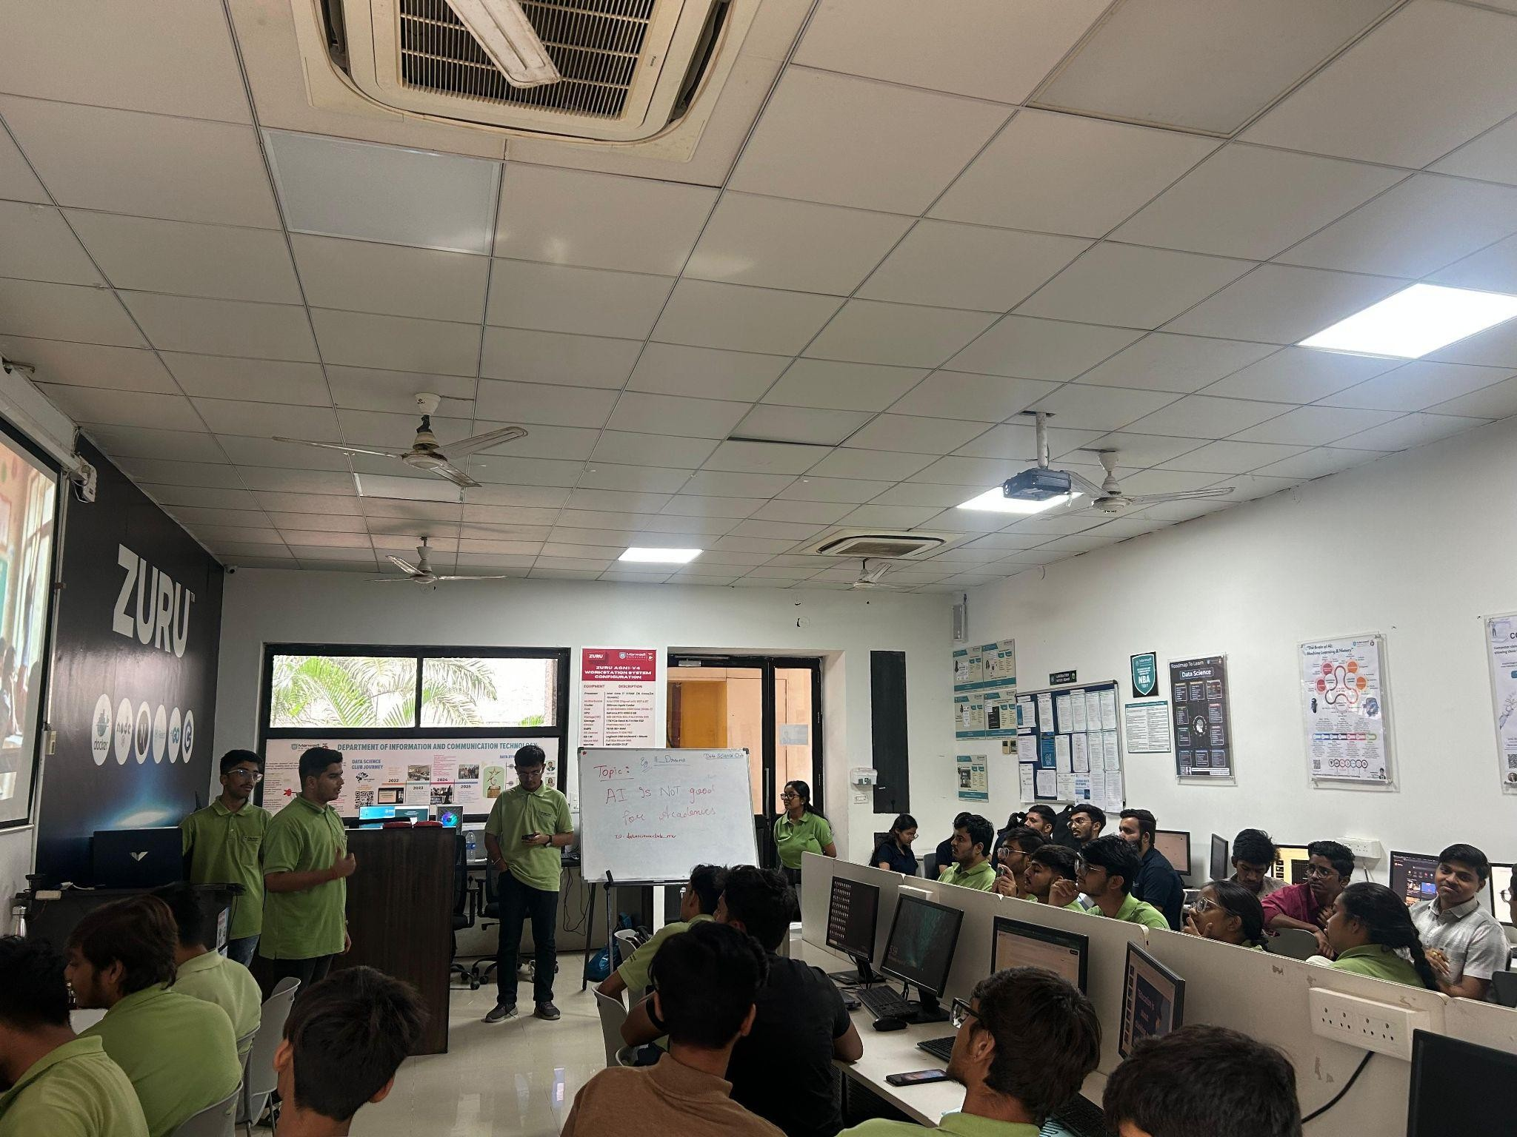
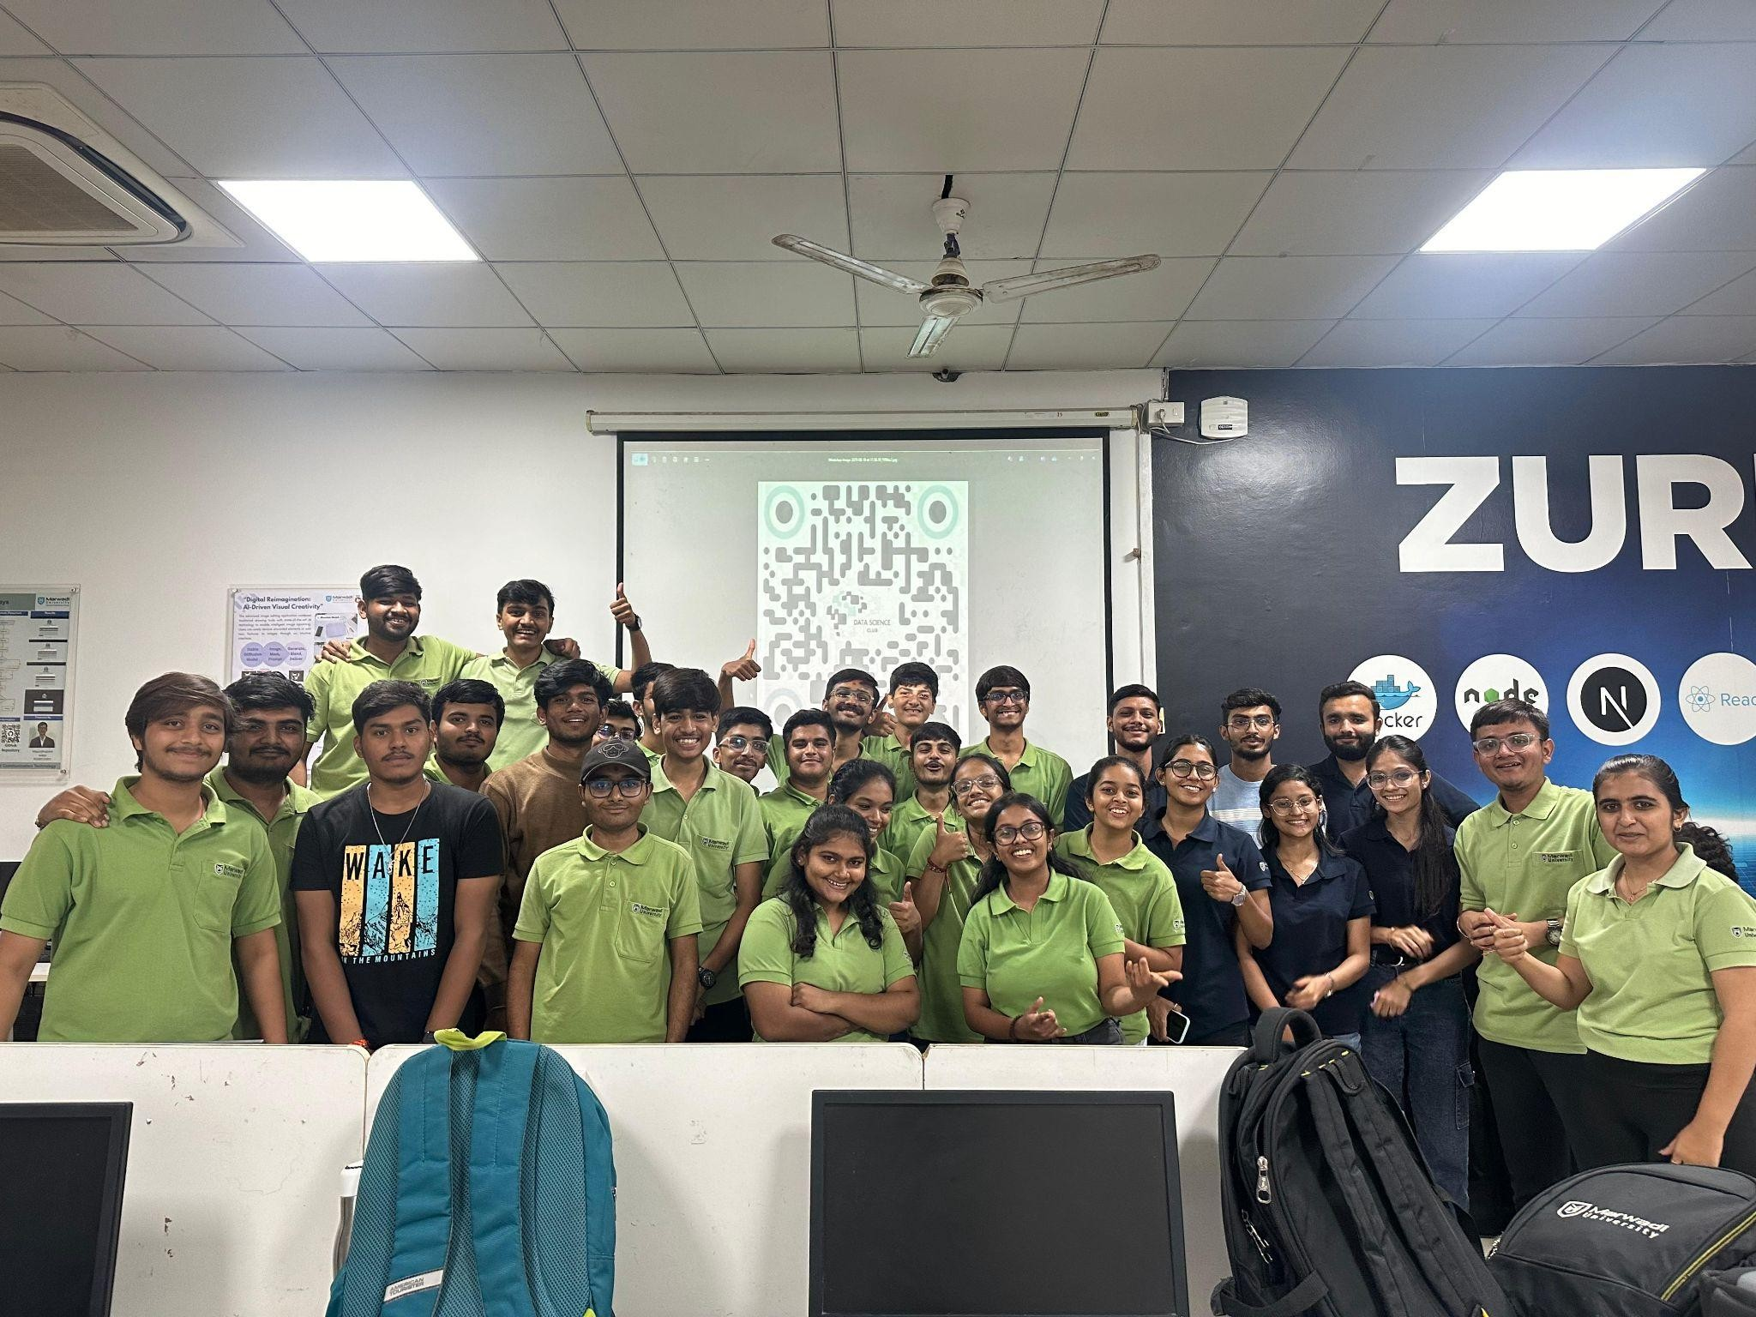



Marwadi Education Foundation ’s Group of Institutions Gauridad Campus, Rajkot
DEPARTMENT OF INFORMATION AND COMMUNICATION TECHNOLOGY

Participants List:
Sr No. | Name | Department | Semester
 | Vedant gondaliya | ICT | 1
 | Hit Depani | ICT | 1
 | Daksh parmar | ICT | 1
 | Maitra Dhanesha | ICT | 1
 | Smit Pambhar | ICT | 1
 | Yesha joshi | ICT | 1
 | Yash Pandya | CSE AI AND ML | 3
 | Shreya B M | CSE | 3
 | Yash Pandya | CSD(AL AND ML) | 3
 | ZOHAIR SADIKOT | Other | 5
 | Mandeep K Thakkar | ICT | 1
 | Pulind Gadhia | CSE | 1
 | Himanshu Singh | ICT | 1
 | Parmar Harsh Chandreshbhai | ICT | 1
 | LS Sai Charan | ICT | 1
 | Vedant Bagthariya | ICT | 1
 | KH Maruthi prasanna | ICT | 1
 | DEEP GADARA MANISHKUMAR | ICT | 1
 | M.Govardhan reddy | MSC - DS | 1
 | JILL SHAILESH PATEL | CSE in AIML | 1
 | M.madhu mohan kumar | ICT | 1
 | Kaushik ajani | CSE | 3
 | Papun Jena | ICT | 1
 | Labdhi Valani | ICT | 3
 | Om Nagar | ICT | 1
 | GANGA VENISH | ICT | 3
 | Rajdeep Jadeja | ICT | 1
 | Moksha Vora | ICT | 3
 | manav chotai | ICT | 1
 | Yamuna Sri sai pasam | MSC - DS | 1
 | Mit chodvadiya | CE | 3
 | Anirudh Kumar | ICT | 1
 | Priyanka pandya | ICT | 1
 | Aman Kumar | MSC - DS | 1
 | Dasari Nihal Nagu | ICT | 1
 | D.Nihal Nagu | MSC - DS | 1
 | Vidhi Ranpura | MSC - DS | 1
 | M. sai kamal | ICT | 1
 | Hardik Nandaniya | ICT | 1
 | Dakshesh Pravinbhai Parmar | ICT | 1
 | K.shrujith | ICT | 1

Coordinators of the event:
- Rudra Miyani
- Hitarthi Pansuriya
- Dhyana Kothari
- Akshat Shah

